WEEK 9 — HADHI VARDHANI K
The kc_house_data.csv dataset was imported into Power BI. It contained housing details such as property ID, sale date, price, number of bedrooms and bathrooms, living area, and lot area. I selected Transform Data to clean and prepare the data before loading it.
The dataset was opened in Power Query Editor, where I checked the column headers and data types. The table was named Housing, and the initial changes made to the data were visible in the Applied Steps pane.
I enabled Column Quality, Column Distribution, and Column Profiling to check the dataset for valid values, errors, empty values, and distinct values. This helped me understand the quality of the data before making further changes.
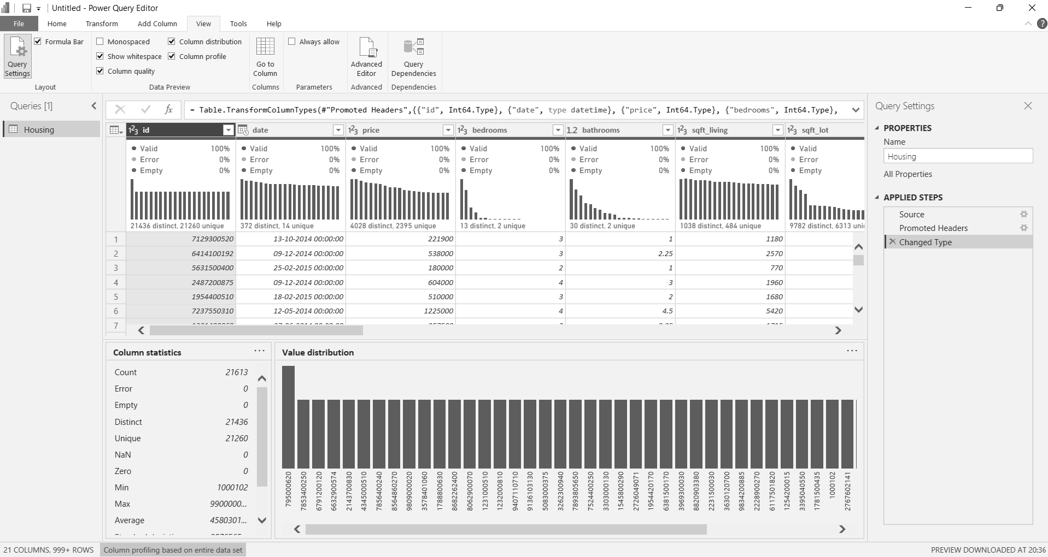

Next, I reviewed the data types of the columns and adjusted them where needed. The date column was set to the appropriate date/time type, the price column was formatted as currency, and the zipcode column was changed to text to preserve its format.
I extracted the year from the date column and renamed the new column Sale Year. This makes it easier to analyse property sales by year.
Similarly, I extracted the month number from the date column and renamed it Sale Month. This field can be used to group and compare sales across different months.
I created a custom column called Property Age at Sale using the formula:
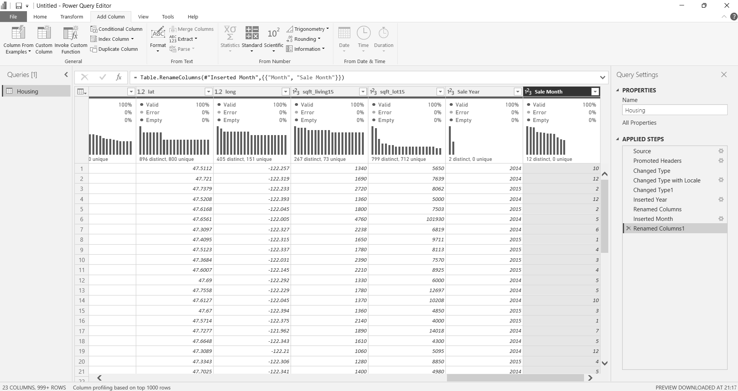
Date.Year([date]) - [yr_built]
This calculates how old a property was when it was sold by subtracting its construction year from the sale year.
After creating the column, I checked the calculated values and set its data type to a whole number so it could be used for further analysis.
I then created a custom column named Price per SqFt using the formula:
[price] / [sqft_living]
This calculates the price per square foot of living space, making it easier to compare the prices of properties of different sizes. I checked the results and set the column to a suitable numeric data type.
Next, I created a column named Total Area using the formula:
[sqft_living] + [sqft_lot]
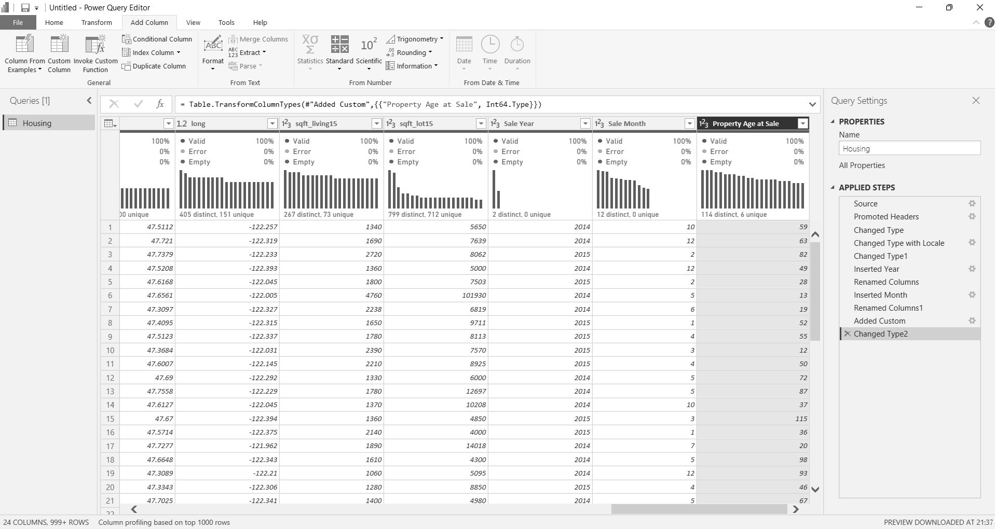This adds the living area and lot area together to provide a combined area value for analysis. The calculated values were checked, and the column was set to a whole number.
I added another custom column called Is Renovated using the formula:
if [yr_renovated] > 0 then "Yes" else "No"
This marks a property as Yes if it has a recorded renovation year and No otherwise. The new column was set to the text data type.
To group properties by their living area, I created a column named Property Size using the following conditions:
- Below 1,000 sq. ft. — Small
- Below 2,000 sq. ft. — Medium
- Below 4,000 sq. ft. — Large
- 4,000 sq. ft. and above — Luxury
The new column displayed the categories Small, Medium, Large, and Luxury, making it easier to compare properties by size.
I also created a custom column named Price Tier to group properties according to their sale price. The categories were assigned as follows:
- Below $250,000 — Budget
- Below $500,000 — Mid-Range
- Below $1,000,000 — Premium
- $1,000,000 and above — Luxury
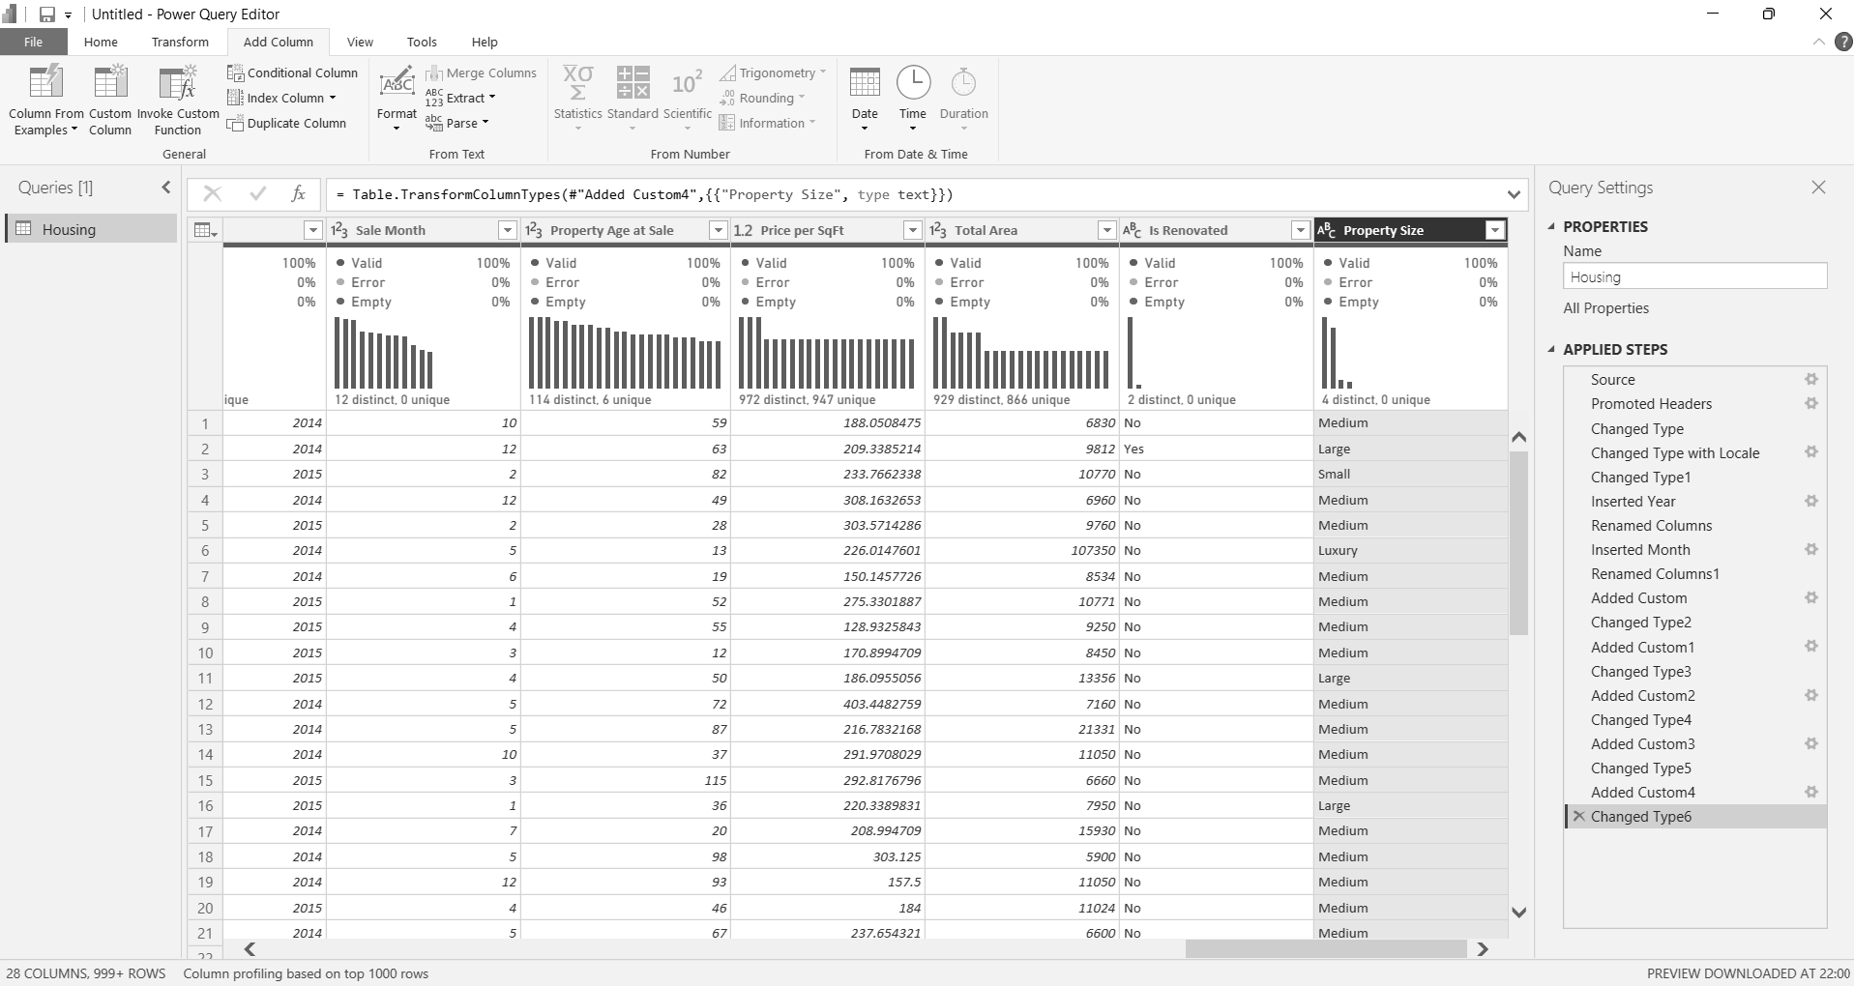
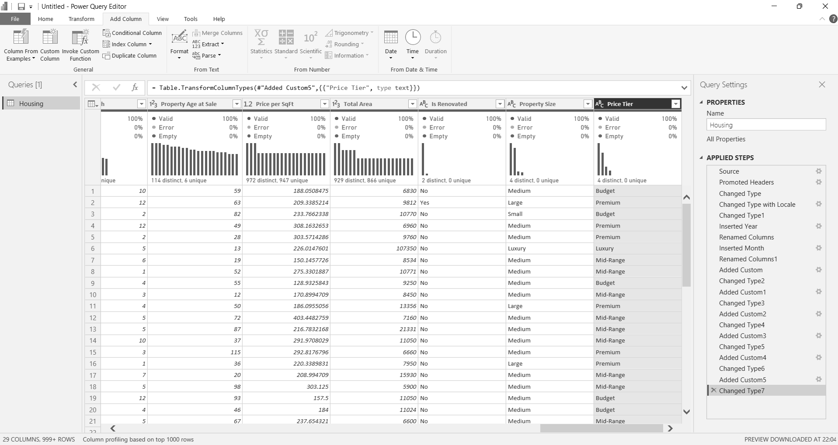After creating the column, I checked the assigned categories and set the data type to text for categorical analysis.
I then filtered the bedrooms column and unchecked the value 0. This removed properties with zero bedrooms from the dataset, as required by the assignment.
Next, I applied a filter to the bathrooms column to keep only properties where the bathroom count was greater than zero. This excluded properties with zero bathrooms from the data.
Finally, I opened Model view in Power BI to review the Housing table and its columns. I checked that the newly created fields, including Is Renovated, Price Tier, Property Age at Sale, Property Size, Sale Month, and Sale Year, were available in the table.


